Ex No : 3 Design the front-end part of the application using

Angular Js and React JS

Date : 08/08/24

1. Include the following Features of AngularJS to build a web application for your chosen idea

Filters

1. Dependency Injection
2. Services
3. Directives
4. Modules
5. Animations

2. Implement the Routing and Form Handling for developing a web application using React JS

**Aim**: To implement above feature by AngularJS and React Js for Event Management.

**Code:**

**<!DOCTYPE html>**

**<html lang="en" ng-app="jobPortalApp">**

**<head>**

**<meta charset="UTF-8">**

**<title>Job Portal</title>**

**<script src="https://ajax.googleapis.com/ajax/libs/angularjs/1.8.2/angular.min.js"></script>**

**<script src="https://ajax.googleapis.com/ajax/libs/angularjs/1.8.2/angular-route.min.js"></script>**

**<script src="https://ajax.googleapis.com/ajax/libs/angularjs/1.8.2/angular-animate.min.js"></script>**

**<style>**

**body {**

**font-family: Arial, sans-serif;**

**}**

**.navbar {**

**background: #333;**

**color: white;**

**padding: 1em;**

**}**

**.navbar a {**

**color: white;**

**margin: 0 1em;**

**text-decoration: none;**

**}**

**.content {**

**padding: 2em;**

**}**

**img {**

**max-width: 100%;**

**height: auto;**

**}**

**.user-card, .employee-card {**

**border: 1px solid #ccc;**

**padding: 1em;**

**margin: 1em 0;**

**}**

**.fade {**

**transition: opacity 0.5s ease;**

**}**

**.fade.ng-enter {**

**opacity: 0;**

**}**

**.fade.ng-enter-active {**

**opacity: 1;**

**}**

**.fade.ng-leave {**

**opacity: 1;**

**}**

**.fade.ng-leave-active {**

**opacity: 0;**

**}**

**.job-list {**

**list-style-type: none;**

**padding: 0;**

**}**

**.job-list li {**

**border: 1px solid #ccc;**

**padding: 1em;**

**margin: 1em 0;**

**}**

**.slide {**

**transition: transform 0.5s ease;**

**}**

**.slide.ng-enter {**

**transform: translateX(100%);**

**}**

**.slide.ng-enter-active {**

**transform: translateX(0);**

**}**

**.slide.ng-leave {**

**transform: translateX(0);**

**}**

**.slide.ng-leave-active {**

**transform: translateX(-100%);**

**}**

**.rotate {**

**animation: rotateIn 1s;**

**}**

**@keyframes rotateIn {**

**0% {**

**transform: rotate(-200deg);**

**opacity: 0;**

**}**

**100% {**

**transform: rotate(0);**

**opacity: 1;**

**}**

**}**

**</style>**

**</head>**

**<body>**

**<div class="navbar">**

**<a href="#!/">Welcome</a>**

**<a href="#!/login">Login</a>**

**<a href="#!/signup">Signup</a>**

**<a href="#!/home">Home</a>**

**<a href="#!/profile">Profile</a>**

**<a href="#!/addjob">Add Job</a>**

**<a href="#!/myjobs">My Jobs</a>**

**<a href="#!/employees">Employees</a>**

**<a href="#!/logout">Logout</a>**

**</div>**

**<div class="content" ng-view class="fade"></div>**

**<script>**

**angular.module('jobPortalApp', ['ngRoute', 'ngAnimate', 'authModule', 'jobModule', 'profileModule', 'employeeModule'])**

**.config(function($routeProvider) {**

**$routeProvider**

**.when('/', {**

**templateUrl: 'welcome.html',**

**controller: 'MainController'**

**})**

**.when('/login', {**

**templateUrl: 'login.html',**

**controller: 'LoginController'**

**})**

**.when('/signup', {**

**templateUrl: 'signup.html',**

**controller: 'SignupController'**

**})**

**.when('/home', {**

**templateUrl: 'home.html',**

**controller: 'HomeController'**

**})**

**.when('/profile', {**

**templateUrl: 'profile.html',**

**controller: 'ProfileController'**

**})**

**.when('/addjob', {**

**templateUrl: 'addjob.html',**

**controller: 'CreateJobsController'**

**})**

**.when('/myjobs', {**

**templateUrl: 'myjobs.html',**

**controller: 'MyJobsController'**

**})**

**.when('/employees', {**

**templateUrl: 'employees.html',**

**controller: 'EmployeesController'**

**})**

**.when('/employees/:employeeId', {**

**templateUrl: 'employeeDetails.html',**

**controller: 'EmployeeDetailsController'**

**})**

**.otherwise({**

**redirectTo: '/'**

**});**

**})**

**.animation('.fade', function() {**

**return {**

**enter: function(element, done) {**

**element.css({ opacity: 0 });**

**element.animate({ opacity: 1 }, done);**

**},**

**leave: function(element, done) {**

**element.animate({ opacity: 0 }, done);**

**}**

**};**

**})**

**.animation('.slide', function() {**

**return {**

**enter: function(element, done) {**

**element.css({ transform: 'translateX(100%)' });**

**element.animate({ transform: 'translateX(0)' }, done);**

**},**

**leave: function(element, done) {**

**element.animate({ transform: 'translateX(-100%)' }, done);**

**}**

**};**

**})**

**.animation('.rotate', function() {**

**return {**

**enter: function(element, done) {**

**element.css({ transform: 'rotate(-200deg)', opacity: 0 });**

**element.animate({ transform: 'rotate(0)', opacity: 1 }, done);**

**}**

**};**

**});**

**angular.module('authModule', [])**

**.service('AuthService', function() {**

**var user = {**

**username: '',**

**age: '',**

**department: '',**

**domain: '',**

**interests: '',**

**languages: '',**

**place: ''**

**};**

**return {**

**login: function(credentials) {**

**user.username = credentials.username;**

**},**

**getUser: function() {**

**return user;**

**},**

**updateUser: function(details) {**

**angular.extend(user, details);**

**}**

**};**

**})**

**.controller('LoginController', function($scope, AuthService, $location) {**

**$scope.login = function(credentials) {**

**AuthService.login(credentials);**

**$location.path('/home');**

**};**

**})**

**.controller('SignupController', function($scope, $location) {**

**$scope.signup = function(user) {**

**$location.path('/login');**

**};**

**});**

**angular.module('jobModule', [])**

**.service('JobService', function() {**

**var jobs = [];**

**return {**

**addJob: function(job) {**

**jobs.push(job);**

**},**

**getJobs: function() {**

**return jobs;**

**}**

**};**

**})**

**.controller('CreateJobsController', function($scope, JobService) {**

**$scope.job = {};**

**$scope.createJob = function() {**

**JobService.addJob($scope.job);**

**$scope.job = {};**

**};**

**})**

**.controller('MyJobsController', function($scope, JobService) {**

**$scope.jobs = JobService.getJobs();**

**})**

**.controller('HomeController', function($scope) {})**

**.controller('JobApplicationsController', function($scope, $routeParams) {**

**$scope.jobId = $routeParams.jobId;**

**})**

**.controller('AcceptedApplicantsController', function($scope) {});**

**angular.module('profileModule', [])**

**.controller('ProfileController', function($scope, AuthService) {**

**$scope.user = AuthService.getUser();**

**$scope.updateProfile = function() {**

**AuthService.updateUser($scope.user);**

**};**

**})**

**.directive('userCard', function() {**

**return {**

**restrict: 'E',**

**template: '<div class="user-card"><h3>{{user.username}}</h3></div>',**

**scope: {**

**user: '='**

**}**

**};**

**});**

**angular.module('employeeModule', [])**

**.service('EmployeeService', function() {**

**var employees = [];**

**return {**

**addEmployee: function(employee) {**

**employees.push(employee);**

**},**

**getEmployee: function(id) {**

**return employees.find(emp => emp.id === parseInt(id));**

**},**

**getEmployees: function() {**

**return employees;**

**},**

**deleteEmployee: function(id) {**

**employees = employees.filter(emp => emp.id !== parseInt(id));**

**}**

**};**

**})**

**.controller('EmployeeDetailsController', function($scope, $routeParams, EmployeeService, $location) {**

**var employeeId = $routeParams.employeeId;**

**$scope.employee = EmployeeService.getEmployee(employeeId);**

**$scope.deleteEmployee = function() {**

**if (confirm('Are you sure you want to delete this employee?')) {**

**EmployeeService.deleteEmployee($scope.employee.id);**

**$location.path('/employees');**

**}**

**};**

**})**

**.controller('EmployeesController', function($scope, EmployeeService, AuthService) {**

**$scope.employees = EmployeeService.getEmployees();**

**$scope.currentUser = AuthService.getUser();**

**if ($scope.currentUser.username) {**

**let exists = $scope.employees.some(emp => emp.username === $scope.currentUser.username);**

**if (!exists) {**

**EmployeeService.addEmployee({**

**id: $scope.employees.length + 1,**

**...$scope.currentUser**

**});**

**$scope.employees.push($scope.currentUser);**

**}**

**}**

**});**

**</script>**

**<!-- Template scripts -->**

**<script type="text/ng-template" id="welcome.html">**

**<div>**

**<h1>Welcome to the Job Portal</h1>**

**<img src="job-portal-1.jpg" alt="Welcome">**

**</div>**

**</script>**

**<script type="text/ng-template" id="login.html">**

**<div class="rotate">**

**<h2>Login</h2>**

**<form ng-submit="login(credentials)">**

**<input type="text" ng-model="credentials.username" placeholder="Username">**

**<input type="password" ng-model="credentials.password" placeholder="Password">**

**<button type="submit">Login</button>**

**</form>**

**</div>**

**</script>**

**<script type="text/ng-template" id="signup.html">**

**<div class="rotate">**

**<h2>Signup</h2>**

**<form ng-submit="signup(user)">**

**<input type="text" ng-model="user.username" placeholder="Username">**

**<input type="password" ng-model="user.password" placeholder="Password">**

**<button type="submit">Signup</button>**

**</form>**

**</div>**

**</script>**

**<script type="text/ng-template" id="home.html">**

**<div class="rotate">**

**<h2>Home Page</h2>**

**<img src="1.jpg" alt="Home">**

**</div>**

**</script>**

**<script type="text/ng-template" id="profile.html">**

**<div class="rotate">**

**<h2>User Profile</h2>**

**<form ng-submit="updateProfile()">**

**<label>Username:</label>**

**<input type="text" ng-model="user.username" disabled>**

**<label>Age:</label>**

**<input type="number" ng-model="user.age">**

**<label>Department:</label>**

**<input type="text" ng-model="user.department">**

**<label>Domain:</label>**

**<input type="text" ng-model="user.domain">**

**<label>Interests:</label>**

**<input type="text" ng-model="user.interests">**

**<label>Languages:</label>**

**<input type="text" ng-model="user.languages">**

**<label>Place:</label>**

**<input type="text" ng-model="user.place">**

**<button type="submit">Update Profile</button>**

**</form>**

**</div>**

**</script>**

**<script type="text/ng-template" id="addjob.html">**

**<div class="rotate">**

**<h2>Add Job</h2>**

**<form ng-submit="createJob()">**

**<input type="text" ng-model="job.title" placeholder="Job Title">**

**<textarea ng-model="job.description" placeholder="Job Description"></textarea>**

**<button type="submit">Add Job</button>**

**</form>**

**</div>**

**</script>**

**<script type="text/ng-template" id="myjobs.html">**

**<div class="rotate">**

**<h2>My Jobs</h2>**

**<ul class="job-list">**

**<li ng-repeat="job in jobs" class="slide">**

**<h3>{{job.title}}</h3>**

**<p>{{job.description}}</p>**

**</li>**

**</ul>**

**</div>**

**</script>**

**<script type="text/ng-template" id="employees.html">**

**<div class="rotate">**

**<h2>Employees List</h2>**

**<ul class="job-list">**

**<li ng-repeat="employee in employees" class="slide">**

**<h3>{{employee.username}}</h3>**

**<p><strong>Department:</strong> {{employee.department}}</p>**

**<p><strong>Domain:</strong> {{employee.domain}}</p>**

**<a href="#!/employees/{{employee.id}}">View Details</a>**

**</li>**

**</ul>**

**</div>**

**</script>**

**<script type="text/ng-template" id="employeeDetails.html">**

**<div class="rotate">**

**<h2>Employee Details</h2>**

**<div class="employee-card">**

**<h3>{{employee.username}}</h3>**

**<p><strong>Age:</strong> {{employee.age}}</p>**

**<p><strong>Department:</strong> {{employee.department}}</p>**

**<p><strong>Domain:</strong> {{employee.domain}}</p>**

**<p><strong>Interests:</strong> {{employee.interests}}</p>**

**<p><strong>Languages:</strong> {{employee.languages}}</p>**

**<p><strong>Place:</strong> {{employee.place}}</p>**

**<button ng-click="deleteEmployee()">Delete</button>**

**</div>**

**</div>**

**</script>**

**</body>**

**</html>**

**Screen Shots:**

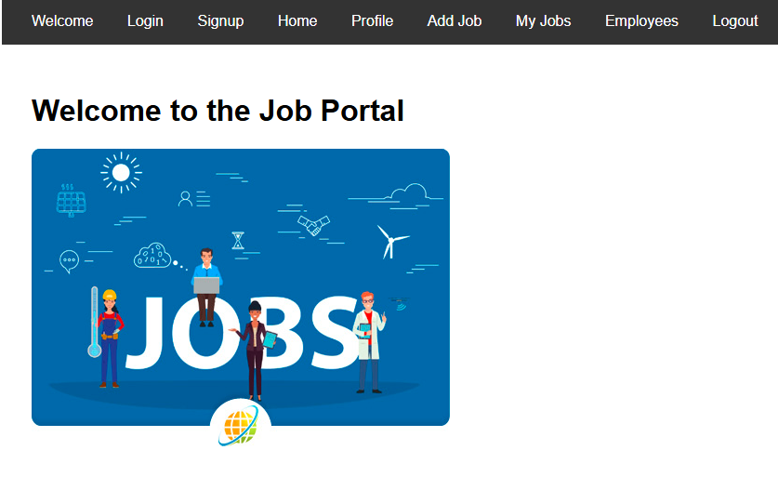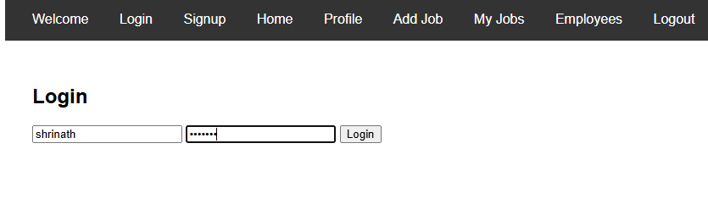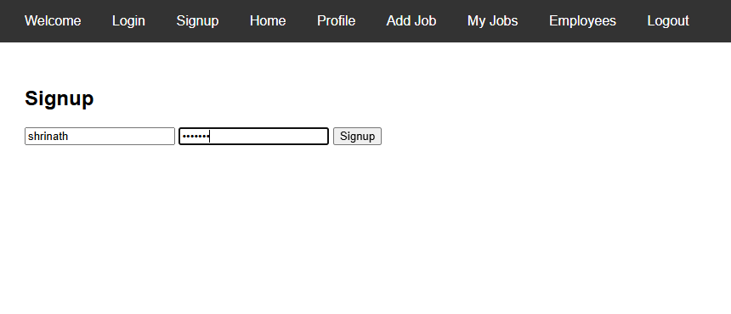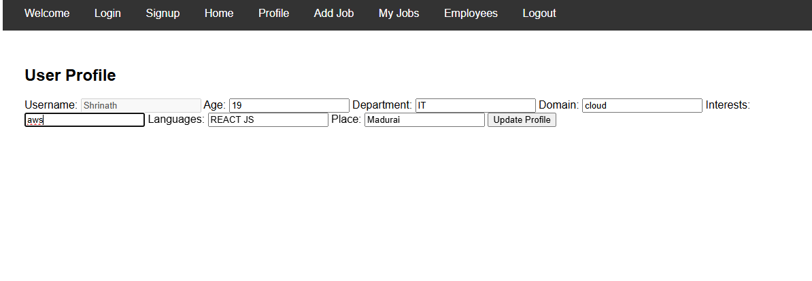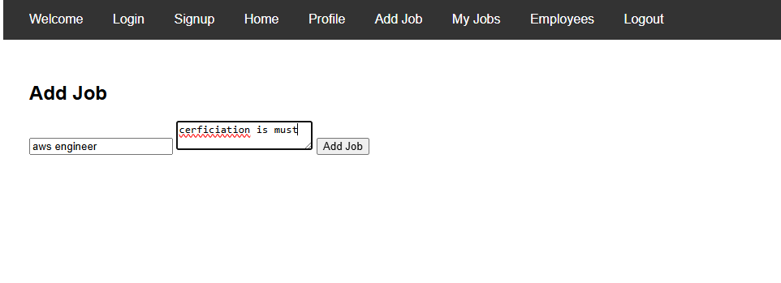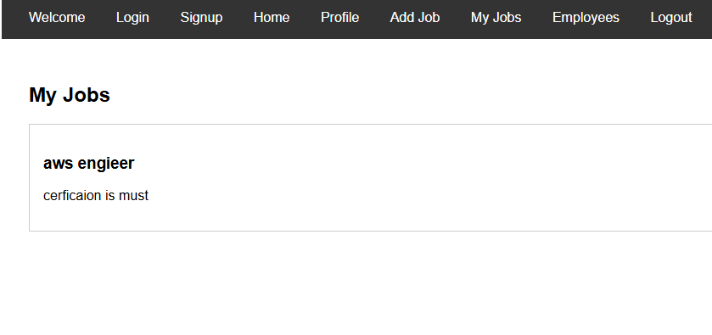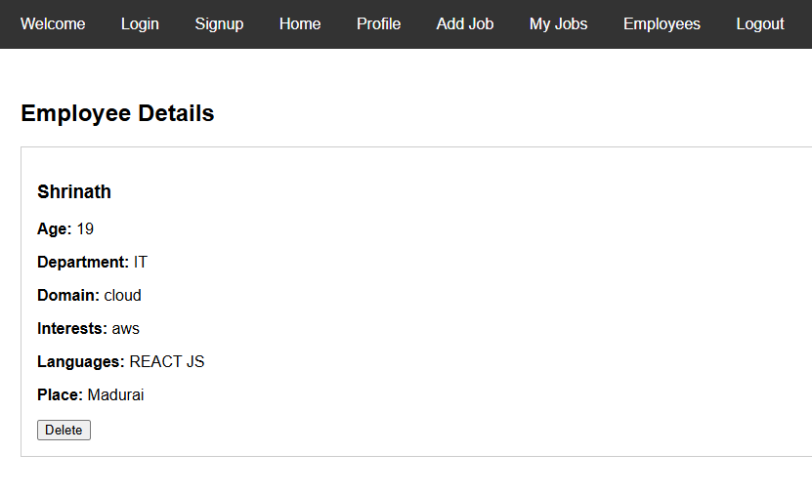



REFRENCES: SCAN ABOVE QR TO VIEW THE PROJECT.

**Result:** Thus successfully developing a web application using React JS, AnugularJS by given features.